Friday, October 13 in the LFA library

4:30 to 10:30 pm with pizza party to follow

3rd ANNUAL

LFA Write-A-Thon

[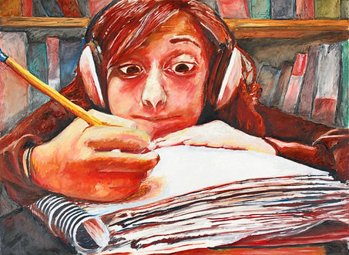](http://blog.syracuse.com/voices/2009/03/234_steinberg.JPG)

You choose the language

– French, English, German or Spanish –

we provide the prompt

What’s your story ?

"Writer's Block," by Nicole Steinberg

Winning stories will be compiled into a published book

Open to all high school students

To sign up by October 7th –

Send an email to writeathonlfa@gmail.com