Viernes 13 de Octubre en la biblioteca del LFA. De las 4:30 de la tarde hasta las 10:30 de la noche, seguido de pizza para compartir
Tercera edición anual
Concurso de escritura
¿Cuál es tu historia?
Tú escoges el idioma
– francés, inglés, alemán o español –
Nosotros te damos el principio de la historia.
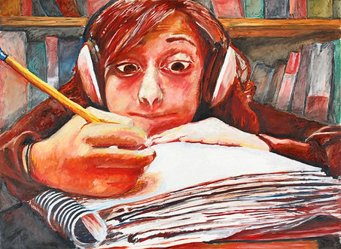
"Writer's Block," por Nicole Steinberg
Para inscribirse antes del 07 de octubre–enviar un correo electrónico a writeathonlfa@gmail.com

Las historias ganadoras serán compiladas en una publicación
Abierto para todos los estudiantes de bachillerato

