Vendredi, 13 octobre à la médiathèque au LFA

16h30h à 22h30h, suivi d’un pizza party
3e Edition du Narrathon LFA
Choisissez la langue
– français, anglais, allemand ou espagnol –
Nous fournirons l’amorce
Quelle est ton histoire?
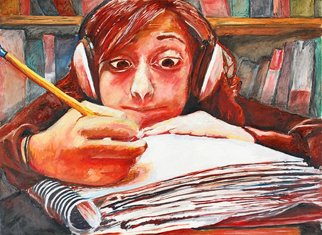
"Writer's Block," by Nicole Steinberg
Inscrivez-vous par email à writeathonlfa@gmail.com avant le 07 octobre

Les histoires des lauréats seront compilées dans un livret.
Ouvert à tous les lycéens

